Name_____________________________________________
The following quotes represent all four Marquez stories we have read in class. Answer the following questions for each:
- What story is the quote from?
- What does the quote mean? Write 2-3 lines of analysis
- How would you explain the quote to someone who has never read Marquez before?
When you have finished answering each question for each quote, choose one quote to focus on. How does the quote relate to the story? What does the quote say about magical realism?
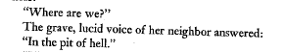

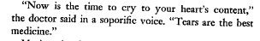

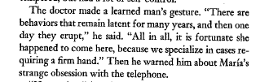

“Light is like water,” I answered him. “You open the tap, and out it comes.”

. The domestic appliances, at the zenith of their poetry, were flying with their own wings around the skies of the kitchen. The instruments from the marching band, that the children used to dance, floated among the colored tropical fish liberated from the mom’s fishbowl, and which were the only living and happy floating things in the vast illuminated swamp.

. They had opened so many lights at the same time that the house had overflowed, and the whole fourth grade of Saint Julian the Hospitalier had drowned in the fifth-floor apartment of 47 Castallana Road, Madrid, Spain, a remote city of burning summers and frozen winds, without sea or river, and whose original landlubber inhabitants had never mastered the science of sailing on light.

Then he noticed that seen close up he was much
too human: he had an unbearable smell of the outdoors, the back side of his wings was
strewn with parasites and his main feathers had been mistreated by terrestrial winds, and
nothing about him measured up to the proud dignity of angels.

The angel was the only one who took no part in his own act. He spent his time trying to
get comfortable in his borrowed nest, befuddled by the hellish heat of the oil lamps and
sacramental candles that had been placed along the wire.

Those consolation miracles, which were more like mocking fun, had already
ruined the angel’s reputation when the woman who had been changed into a spider finally
crushed him completely.

She did her job well, and for a long time, above all during the war years, when reality was more sinister than nightmares.

He moved through the crowd like an invalid elephant, with a child’s curiosity in the inner workings of each thing he saw, for the world appeared to him as an immense wind-up toy with which life invented itself.

Only poetry is clairvoyant

